Test software specification

- Description of the software:

The application is used to test passive antennas. The software is a PC based application written in Python and working on Windows. The software will guide the operator through all steps of the testing process. The software will have a simple FPY screen.

- Hardware set up of a tester:

- PC
- Power Meter: Anritsu MA24510A Power Master
- Signal Generator: Vaunix LMS-163
- Extension Module (frequency multiplier): Farran FES-12-0001
- QR code scanner

The power meter is connected to the PC via USB. The signal generator is connected to the PC via USB. The Extension module is connected to a signal generator. The connection with the signal generator and extension module is through the VISA/SCPI interface. The QR code scanner is connected to the PC via USB.

The extension module Ferran FES-12-0001 is a frequency multiplexer. It multiplies frequency by a given factor. The factor is set up in the software configuration file.

Simple diagram of connections below.
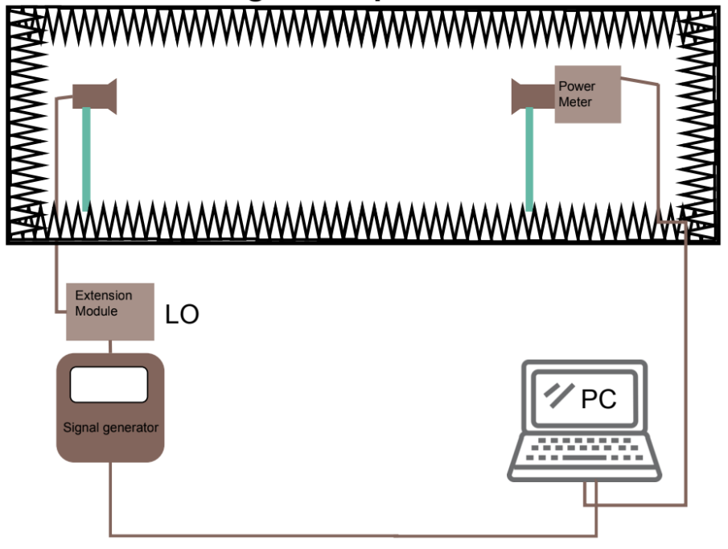
- Antennas specifications:

The software is prepared for 5 types of antennas. Engineers can add new products by preparing a configuration file. Each antenna has from 8 to 40 ports. The ports of the antenna are divided in two groups: horizontal and vertical. Each port is scanned at 11 frequencies.

- Measurement description

The frequency in the transmitter is obtained by dividing the target frequency by a certain factor. For example, if we want to get 76 GHz, we must set 12.66 GHz (75.96 GHz / 6 = 12.66 GHz). The program should be able to change factor 6 (in case it is necessary to replace the equipment).

- Main process flow of the application

Process flow defined in mermaid:

graph TD

%% Define styles
classDef operator fill:#ffe0b2,stroke:#e65100,stroke-width:2px;
classDef software fill:#bbdefb,stroke:#0d47a1,stroke-width:2px;

%% Process flow
O1[Operator: Opens the software]:::operator --> S2[Software: Browses the folder for configuration files]:::software
S2 --> S3[Software: Creates a list of antennas for testing]:::software
S3 --> S4[Software: Displays the home screen]:::software
S4 --> O5[Operator: Logs into the system]:::operator
O5 --> S6[Software: Displays a list of available antennas to test]:::software
S6 --> S7[Software: Resets the serial number list]:::software
S7 --> O8[Operator: Selects the antenna for test]:::operator
O8 --> S9[Software: Loads configuration file for selected antenna]:::software
S9 --> O10[Operator: Selects jig orientation]:::operator
O10 --> S11[Software: Displays port selection window; all ports active by default]:::software
S11 --> O12[Operator: Deselects tracks not to be tested]:::operator
O12 --> O13[Operator: Selects the port for testing]:::operator
O13 --> O14[Operator: Scans golden sample serial number]:::operator
O14 --> S15[Software: Verifies golden sample serial number]:::software
S15 --> O16[Operator: Initiates measurement]:::operator
O16 --> S17[Software: Performs golden sample measurement]:::software
S17 --> S18[Software: Saves results for 11 frequencies to Golden_Measurement]:::software
S18 --> S19[Software: Displays info to test silver sample]:::software
S19 --> O20[Operator: Scans silver sample serial number and program verifies it]:::operator
O20 --> O21[Operator: Initiates the antenna test]:::operator
O21 --> S22[Software: Performs antenna test]:::software
S22 --> S23[Software: Displays status and graph with values and limits]:::software
S23 --> S24[Software: Saves silver sample measurements to database]:::software
S24 --> S25[Software: Displays data entry window]:::software
S25 --> O26[Operator: Scans Order_Number]:::operator
O26 --> O27[Operator: Inserts quantity of antennas in production order]:::operator
O27 --> S28[Software: Waiting for antenna serial number scan]:::software
S28 --> O29[Operator: Scans antenna serial number]:::operator
O29 --> S30{Software: Serial number in list?}:::software
S30 -- Yes --> S31[Software: Serial number already tested]:::software
S31 --> O32[Operator: Retest? Yes/No]:::operator
O32 -- Yes --> O34[Operator: Activates antenna test]:::operator
O32 -- No --> S28
S30 -- No --> S33[Software: Adds antenna serial to list]:::software
S33 --> O34
O34 --> S35[Software: Performs 11 frequency test]:::software
S35 --> S36[Software: Displays status and measurement graph]:::software
S36 --> S37[Software: Sends 11 measurements to database]:::software
S37 --> S38{Software: Any antennas left in production order?}:::software
S38 -- Yes --> S28
S38 -- No --> S39[Software: All antennas tested for this order]:::software
S39 --> O40[Operator: Test next batch? Yes/No]:::operator
O40 -- Yes --> S25
O40 -- No --> S6

- Configuration files for antenna

For each antenna there is a configuration file with test parameters. The files are located in a specific folder. The software will read the folder with configuration files on startup. The configuration files are stored as excel files with two sheets. The first sheet “LIMITS” is for specification of test conditions. The second sheet “CONFIGURATION” is for set up names, serial number definition, etc.

The data dictionary and example of the configuration file is in attachment.

- Description of a software configuration file

The main configuration parameters will be stored in a configuration file. The file is in attachments.

- Description of an operator configuration file

The operator configuration file stores names, surnames, login and passwords of trained operators.

- Description of software logs

Logs with errors and messages should be saved on a local disk in a txt file.

- Description of the database structure

The database is stored on an external server, the software will send the data to the database. The software will use ODBC for connection with the database. The software should check connection with the database prior data transfer.

Extra points:

- Defining the number of NOK antennas after which an engineer should be contacted.

Appendixes:

- Gain Test - configuration file - data dictionary v01.xlsx
- Gain Test - configuration file - data example v01.xlsx
- Gain Test - database - data dictionary v01.xlsx
- Gain Test - database - data example v01.xlsx
- Gain Test - software configuration - data dictionary v01.xlsx
- Gain Test - software configuration - data example v01.xlsx

